Comoros

## GNI per capita and development level

The data set shows the GNI per capita and development level of the country each year.

## # A tibble: 19 x 5  
## country iso3c date GNIperCapita devCategory   
## <chr> <chr> <dbl> <dbl> <chr>   
## 1 Comoros COM 1996 1210. Lower Middle Income  
## 2 Comoros COM 1998 1206. Lower Middle Income  
## 3 Comoros COM 2000 1297. Lower Middle Income  
## 4 Comoros COM 2002 1290. Lower Middle Income  
## 5 Comoros COM 2003 1285. Lower Middle Income  
## 6 Comoros COM 2004 1278. Lower Middle Income  
## 7 Comoros COM 2005 1285. Lower Middle Income  
## 8 Comoros COM 2006 1288. Lower Middle Income  
## 9 Comoros COM 2007 1273. Lower Middle Income  
## 10 Comoros COM 2008 1287. Lower Middle Income  
## 11 Comoros COM 2009 1297. Lower Middle Income  
## 12 Comoros COM 2010 1315. Lower Middle Income  
## 13 Comoros COM 2011 1337. Lower Middle Income  
## 14 Comoros COM 2012 1345. Lower Middle Income  
## 15 Comoros COM 2013 1375. Lower Middle Income  
## 16 Comoros COM 2014 1372. Lower Middle Income  
## 17 Comoros COM 2015 1359. Lower Middle Income  
## 18 Comoros COM 2016 1374. Lower Middle Income  
## 19 Comoros COM 2017 1395. Lower Middle Income

## GDP growth and economic growth classification

The data set shows the GDP growth and the ecomic growth classification of the country each year.

## # A tibble: 19 x 5  
## country iso3c date GDPannualGrowthRate GDPgrowthCategory4  
## <chr> <chr> <dbl> <dbl> <fct>   
## 1 Comoros COM 1996 -1.29 negative grwoth   
## 2 Comoros COM 1998 1.28 slow growth   
## 3 Comoros COM 2000 10.8 fast growth   
## 4 Comoros COM 2002 2.32 slow growth   
## 5 Comoros COM 2003 2.10 slow growth   
## 6 Comoros COM 2004 1.92 slow growth   
## 7 Comoros COM 2005 2.84 moderate growth   
## 8 Comoros COM 2006 2.65 moderate growth   
## 9 Comoros COM 2007 0.800 slow growth   
## 10 Comoros COM 2008 4.00 moderate growth   
## 11 Comoros COM 2009 3.20 moderate growth   
## 12 Comoros COM 2010 3.80 moderate growth   
## 13 Comoros COM 2011 4.10 moderate growth   
## 14 Comoros COM 2012 3.20 moderate growth   
## 15 Comoros COM 2013 4.50 moderate growth   
## 16 Comoros COM 2014 2.10 slow growth   
## 17 Comoros COM 2015 1.12 slow growth   
## 18 Comoros COM 2016 3.32 moderate growth   
## 19 Comoros COM 2017 3.82 moderate growth

## Development trend

The plot shows the development trend of the country.

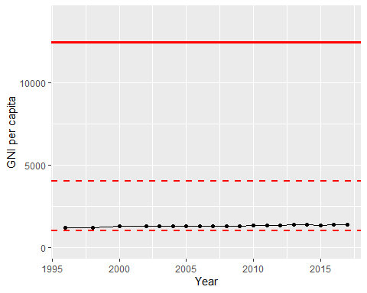

GNI Per Capita Trend